µ-Mapping of Electronic and Structural Properties of Complex Uranium Compounds
By Alexander Gottberg,* João Pedro Ramos,* Claude Degueldre,* Daniel Grolimund,* Camelia N. Borca,* and Thierry Stora*

[*] Dr. Alexander Gottberg, João Pedro Ramos, Dr. Thierry Stora
CERN, EN-STI
CH-1211 Genève 23 (Switzerland)
E-mail: alexander.gottberg@cern.ch; thierry.stora@cern.ch
Dr. Claude Degueldre
Paul Scherrer Institut
5232 Villigen PSI (Switzerland)
Dr. Daniel Grolimund, Dr. Camelia N. Borca
Swiss Light Source, Paul Scherrer Institut
5232 Villigen PSI (Switzerland)

Keywords: uranium carbide, micro-XAS, non-irradiated fuels

Advanced materials based on uranium and thorium refractory compunds are a corner stone for large scale facilities delivering radioactive beams throughout the world. The technique, first pioneered at the Niels Bohr Institute in the 50's, exploits the interaction of an energetic particle beam with a thick target to induce nuclear reactions. The produced isotopes are stopped in the thick target, before they diffuse and are released, serving as a particle source for a secondary beam purified by mass-separation and delivered to experiments active in fundamental nuclear physics and astrophysics.^{[21]} Along the years polyphasic porous uranium carbides became the reference material used in the different facilities across the world. It allows today accessing a wide range of radioisotope beams as for instance illustrated at ISOLDE, CERN.^{[1]}
Uranium-based fuel materials constitute also the chore elements for nuclear electricity production, in which the neutron-induced fission reactions are used to generate the heat for further conversion into electricity. The function of the uranium-based materials is here radically different: the nuclear reaction products must be fully contained in the fuel rods to prevent any detrimental impact on the installations and the environment.^{[24]} Specifically for the development of the next generation IV nuclear power plants, which aims at improving the safety and efficiency of nuclear energy production, active research on new uranium carbide materials is undertaken.^{[24]}
In most nuclear power plants radioisotopes are produced as an undesired side-product of the exothermal fission process of uranium-235 under thermal neutron irradiation. Per contra, in radioactive beam production facilities, the radioisotopes are highly desired and are produced by sub-critical fission of uranium-238 induced by a high-energy neutron or proton driver.
Whereas an idealistic nuclear fuel detains all toxic radioisotopes the perfect ion beam production material releases all products of nuclear reactions instantly. Though antithetic, the material requirements in nuclear power and radioactive ion beam production are determined by the very same microscopic properties, which are accessible in a uniquely comprehensive way by the integrated techniques presented here.
On a fundamental basis, transport properties of actinide compounds, linked with complex localization patterns of the 5f electron shell, is an active field of research. Information of the chemical composition, phase and structure provides the necessary input to elaborate theoretical modeling.^{[7]}
The need for a rational development of novel materials that display different transport properties calls for a careful characterization of their phase, chemical composition, and microstructure. However the intrinsic radiotoxicity of actinides makes this task challenging and thus requires dedicated infrastructures and techniques.^{[8]}
For instance the path to provide a new generation of uranium based materials for particle production was long lacking this information. Only in the recent times has scarce data become available.^{[13]} However a precise modeling of the diffusion and release properties of various isotopes can only be done knowing this information.^{[25]} Indeed, recent data show that high isotope release rates are intimately related with the synthesis of novel type of nanostructures.^{[26]}
We present here data on dense polycrystalline uranium monocarbide and porous polyphasic materials resolved at a submicron scale; this provides for the first time information on phase and porosity which directly influence the rate of release of the various chemical radioisotopes. Specifically extended X-ray adsorption fine structure (EXAFS), X-ray fluorescence (XRF) and micro X-ray diffraction (XRD) using micro-focused synchrotron radiation is reported here. The methodology was developed to prepare samples with high radiotoxocity and to bring them to the beamline X05LA at the Swiss Light Source (SLS), Paul-Scherrer-Institute (PSI), where these investigations took place. This opens up the possibility to extend these studies to a new generation of materials after irradiation, to observe the diffusion or accumulation of chemical species along their operation under energetic particle beam irradiation.
Uranium carbides of different stoichiometry, density and grain size are intensively discussed as future ISOL-type target materials, where currently a porous dicarbide with excess graphite is widely used. Recently proposed were sintered UC matrices of 5 µm to 20 µm grain sizes with densities close to the theoretical density.^{[9]} The isotope production and release of this material was complementally tested at ISOLDE, CERN and IPNO, Orsay, France.^{[23]}
Due to the complexity of these advanced, engineered materials a comprehensive knowledge of properties on the micrometric length scale is crucial to understand the global diffusion properties first of pristine and later under or after high energy proton irradiation. Therefore a series of microscopic electronic, chemical and structural investigations were performed on the concerned uranium-based materials. With an incidence exciting synchrotron beam close or at the uranium L_{III} absorption edge at 17.2 keV and a set of two X-ray detectors for energy or position dispersive detection respectively allow for simultaneous X-ray diffraction (XRD) powder pattern mapping and X-ray florescence spectroscopy (XFS). Returning with the 1.4 µm² synchrotron focus to a chosen sample position, extended X-ray absorption fine structure (EXAFS) measurements can be performed at a dedicated spot of interest, identified in the XFS or XRD maps.
So far a series of three non-irradiated materials were studied, clearly illustrating the power of the applied techniques to understand complex, multiphasic, structured radioactive materials. Samples were either prepared for measurement by producing a defined micrometric cross section using focused ion beam (FIB) milling in a scanning electron microscope (SEM) or they were investigated in their pristine macroscopic pellet shape.
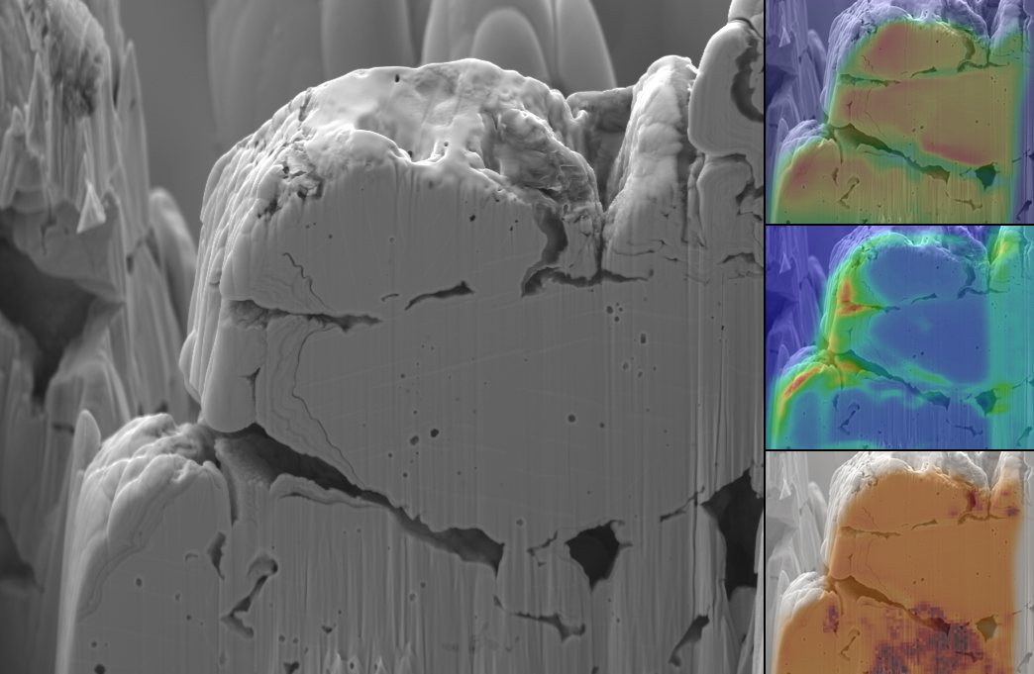
U
Lα₁
Ga
Kα₁
α-UC₂
(110)
10µm
Figure 1. SEM image (electron energy 2kV) of a 7µm thick cross section through a uranium mixed carbide particle as prepared by the FIB technique (left). X-ray fluorescence emission map collected for the same particle in steps of 0.5µm at the U Lα₁ (top) and the Ga Kα₁ (middle) emission line. For Ga the false-color intensity scale is enhanced by 10⁴ compared to the uranium image. XRD microscopy (bottom) showing the α-UC₂ (110) reflex intensity throughout the sample.

Porosity and microscopic distribution of both, chemical species and crystallographic phases are crucial parameter for most nuclear materials. Fig.1 presents a series of sample images giving a broad overview over these properties:
From measurements of surface topography of these compounds the typical grain size was reported to be between 20µm and 50µm while bulk observations have never previously been performed.^{[6,13]} Already the SEM image of a FIB thin cut reveals sub-particles of 1µm to 3µm, an observation that has major impact on the modeling of the release of fission fragments. A number of micro- and sub-micrometric pores can be identified; some of them appear to be closed as they are surrounded by material, others are connected to the surface of the particle. An observation, which could be made while stripping layer per layer was that these pores are in fact interconnected to a large extend, which results in a major fraction of the porosity to be open.
It is XFS, measured at the uranium U Lα₁ fluorescence transition that shines further light on the 3-dimensial structural arrangement. The upper right panel in Fig. 1 displays the XRF map of the same sample, showing the intensity of the uranium Lα₁ transition at 13.6 keV for each position of the synchrotron beam spot on the sample. This intensity is proportional to the number of uranium atoms seen by the micro-focused synchrotron beam, the subshell photoionization cross section and the relative fluorescence yield. Therefore, this image directly represents the distribution of uranium density, hence pores, since the cut is believed to be made in a region of a single overall uranium carbide stoichiometric phase, where the C/U ratio is subject to small changes only. Comparing the SEM and the XFS map indicates that most pores are connected to each other and finally to the periphery of the uranium carbide particle and therefore being part of the material’s open porosity.

During the FIB-based sample preparation a focused gallium beam was used leaving traces of Ga deposited on the particle’s surface and the pore boundaries. The distribution of this contamination can be observed following the intensity of the Ga Kα₁ emission line throughout the surface. Microscopic XFS mapping is of significant importance when following the segregation or precipitation of fission fragments after irradiation, which will have major influence on particle diffusion and release properties. The intensity of the transition indicates sensitivity in the parts per billion regime, a concentration which is well within the production yield of most elements during the operation in either a nuclear power plant or a radioisotope production facility.

The electronic structure of compounds, where uranium occupies different valance states is of fundamental interest to understand the transition from localized to itinerant 5f electronic band structures.^{[7]} While the L_{III} absorption energies are known for many uranium compounds, the edge energies for the respective carbides have yet only been reported recently for uranium monocarbide.^{[10,15]} Fig. 2 displays the EXAFS spectra measured on the uranium L_{III} absorption edge for the monocarbide (top) and the dicarbide (bottom). In both cases the synchrotron beam was focused to a size of 1µm² to 3µm² and the EXAFS spectra show strong oscillatory features, which indicates that the uranium atoms are located within a uniform lattice within this micrometric scale.
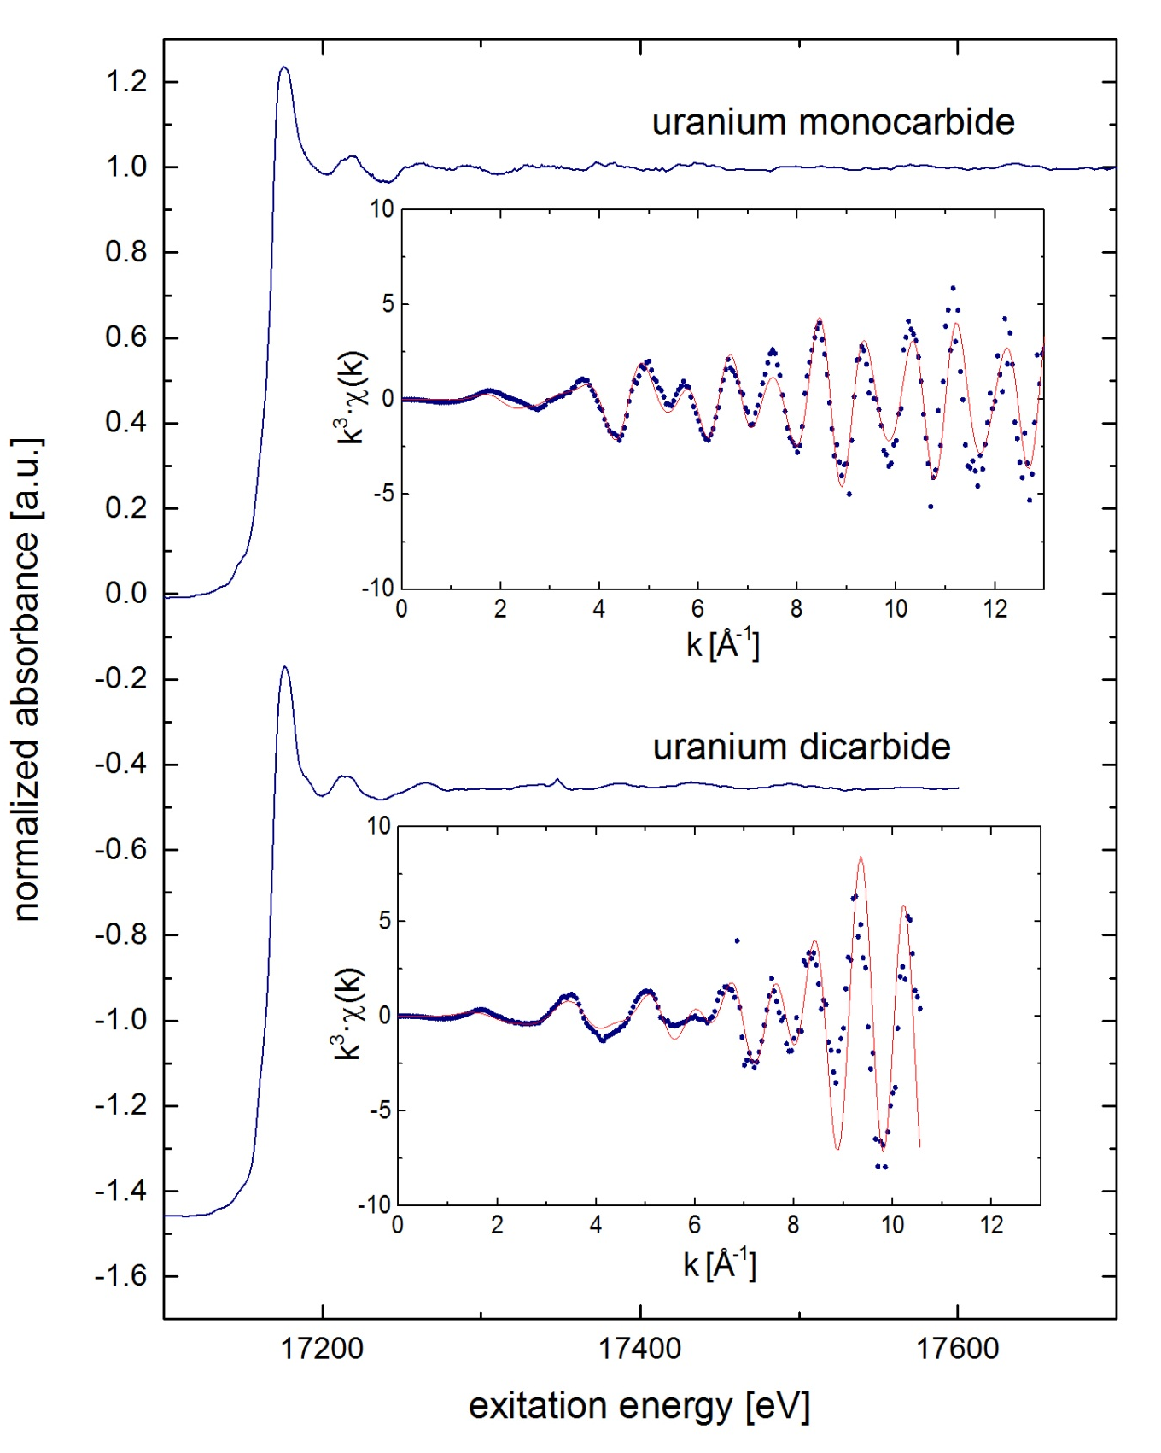
Figure 2. EXAFS spectra of uranium monocarbide measured with a 3µm² synchrotron focus (top) and uranium dicarbide measured with a 1.4µm² synchrotron focus (bottom). k³-weighted absorbance as inset respectively (blue dots – data, red line – IFEFFIT fit for the respective structure as described in the text).

In order to extract the threshold energies the data was reduced including pre-edge background subtraction, followed by spline fitting and normalization. Using the Athena^{[10]} code the position of the uranium L_{III} absorption edge was found to be E₀^{UC} = 17168.5(9) eV, in agreement with N. Vigier et al.^{[15]} As expected from measurements and predictions for other U(IV) ions, the edge experiences a chemical shift towards higher energies for uranium dicarbide for which it is found here at E₀^{UC2} = 17170.0(6) eV.^{[16,17]}
Both the UC and the UC₂ data were fitted using the IFEFFIT code after background subtraction.^{[19]} The energy threshold shift ε₀ and the global amplitude factor S₀² where left open for the fit. For the EXAFS measurements sample positions were chosen from the XRD and XFS patterns comparatively where well defined structures were identified corresponding to space group Fm3m and I4/mmm for UC and UC₂ respectively. Further details for both fits are presented in the supporting material. The fits show good agreement with the lattices identified in the XRD patterns proving that EXAFS measurements can be exploited in the current setup to identify the electronic environment of prospective trace contaminations or fission fragments making use of their distinct sensitivity.
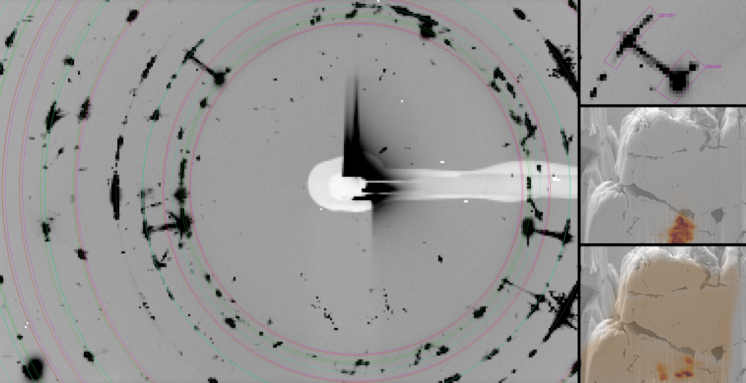
α-UC₂
(002)
UC
(200)
1
2
1
2
Figure 3. Image showing the superimposed XRD patterns of 10770 consecutive sample positions recorded during the full mapping (left). All major features can be assigned to low-index reflections of α-UC₂, β-UC₂, UC or UO₂ within the sample and additional Mo from the sample holder. A zoom on two reflexes (top right) reveals an inelastic scattering path originating from two coexisting sub-micrometric phase accumulations of α-UC₂ (middle) and UC (bottom) being stoichiometrically stabilized over a large range even at high temperatures.

µXRD can be used to reveal phase distributions in a micrometric scale but also 3-dimensional complex structural ordering phenomena at the same time. As shown in Fig. 3 a wide range of phases can be identified and their distribution mapped. Single features in the pattern from Fig. 3 correspond to specific orientations within a certain crystallographic phase and high-symmetry reflection. All major reflexes could be assigned to either α-UC₂, β-UC₂, UC or UO₂. Additional molybdenum reflexes originate from the sample holder, where the sample was attached to by a carbon strip. A Rietveld fit after azimuthal integration (see supporting material) using the XRDUA code of the superimposed pattern exposes the contribution of each phase.^{[22]} For the sample shown in Fig. 3 this is mainly α-UC₂ (76%), followed by UC (17%) and β-UC₂ (≈2%).
Besides this detailed insight into the microscopic phase distribution, additional characteristics can be identified. Especially notable are the tails along Δq or 2ϑ connecting two or more reflexes of different phases caused by inelastic scattering (e.g. as seen in Fig. 3 top right). Uranium dicarbide is known to be a material of high stability during high energy proton irradiation at high temperatures of more than 2300K. However it was not known, where this outstanding stability arises from. Following the spatial distribution of these features provides an explanation for the high thermal stability. UC₂ and UC are coexisting in sub-micrometric crystallites over a range of several micrometers due to stoichiometric imperfections favoring one of the two compounds. Sintering is therefore restricted until additional carbon defuses into this zone and transforms the mono- to the dicarbide or until the dicarbide decomposes to monocarbide and graphite. All these reactions are thermodynamically unfavorable even at elevated temperatures, causing the indirect structural stabilization.^{[19]}
In a second sample investigated from the same batch but with a different thermal history these tails of inelastic scattering are nearly absent. In this sample the fraction of cubic UC derived from the Rietveld fit is well below 1%.

References
[1] E. Kugler, Hyperfine Interactions 2000, 129, 23; L. P. Gaffney et al., Nature 497 (2013) 199.
[2] A. Kraut, N. Müller, G. Neumann; J. Nuc. Materials 1972, 45, 163-170
[3] L. Biasetto, P. Zanonato, S. Carturan, P. Di Bernardo, P. Colombo, A. Andrighetto, G. Prete; J. Nuc. Materials 2010, 404, 68-76
[4] J. R. J. Bennett, in: K.W. Shepard (Ed.), Proceedings of the Eight International Conference on Heavy, Ion Accelerator Technology, Argonne National Laboratory, Chicago, 5 to 9 October 1998, AIP Conference Proceedings 473, AIP, New York, p. 490 (1999)
[5] S. Fernandes, PhD Thesis EPFL (2011) http://cdsweb.cern.ch/record/1312950/
[6] A. Gottberg, Online Tests of a High Density UC target at CERN-ISOLDE, ARIS (2011) https://iks32.fys.kuleuven.be/indico/contributionDisplay.py?contribId=204&sessionId=4&confId=0
[7] Y. Baer, J. K. Lang, Phys. Rev. B 1980, 21, 2060
[8] C. Mieszczynski, C. Degueldre, G. Kuri, J. Bertsch , C. N. Borca, Prog. in Nuc. Ener., 2012, 57, 130
[9] V. N. Panteleev, O. Alyakrinskiy, M. Barbui, A. E. Barzakh, D. V. Fedorov, V. S. Ivanov, G. Lhersonneau, K. A. Mezilev, P. L. Molkanov, F. V. Moroz, S. Yu. Orlov, L. Stroe, L. B. Tecchio, M. Tonezzer, Yu. M. Volkov, Eur. Phys. J. A, 2009, 42, 495-501
[10] E. A. Hudson, J. J. Rehr, J. J. Bucher, Phys. Rev. B 1995, 52, 13815-13825
[11] J. M. Lawrence, M. L. den Boer, R. D. Parks, J. L. Smith, Phys. Rev. B, 1984, 29, 568-575
[12] H. Matsui, J. of Nuc. Sci. and Tech., 1981, 18, 922-929
[13] C. Lau, B. Roussière, D. Verney, O. Bajeat, F. Ibrahim, F. Clapier, E. Cottereau, C. Donzaud, M. Ducourtieux, S. Essabaa, D. Guillemaud-Mueller, F. Hosni, H. Lefort, F. Le Blanc, A.C. Mueller, J. Obert, N. Pauwels, J.C. Potier, F. Pougheon, J. Proust, J. Sauvage,
A. Wojtasiewicz, NIM B 2003, 204, 246
[14] A. L. Bowman, G. P. Arnold, W. G. Witteman, T. C. Wallace and N. G. Nereson, Acta Cryst. 1966, 21, 670
[15] N. Vigier, C. Den Auwer, C. Fillaux, A. Maslennikov, H. Noël, J. Roques,
D. K. Shuh, E. Simoni, T. Tyliszczak, and P. Moisy, Chem. Mater. 2008, 20, 3199-3204
[16] B. Ravel, M. Newville, J. Synchrotron Rad. 2005, 12, 537
[17] Ch. Hennig, Phys. Rev. B 2007, 75, 035120
[18] Dealattes et al. Phys. Rev. B 2003, 35
[19] J. J. Rehr, R. C. Albers, Rev. Mod. Phys. 2000, 72, 621
[20] P.Y. Checalier et al., J. Nuc. Mat. 2001, 288, 100-129
[21] A. Herlert, Nucl. Phys. News 2010, 20, 5-12
[22] W. De Nolf , K. Janssens, Surf. Interface Anal. 2010, 42, 411-418
[23] A. Gottberg, A. Andrighetto, P. Bricault, E. Cottereau, P. Delahaye, H. Franberg, F. Gramegna, I. Günther-Leopold, C. Jost, C. Lau, R. Luis, N. Lecesne, T. Marchi, M. G. St.-Laurant, M. Cheikh Mhamed, V. Panteleev, B. Roussiere, D. Scarpa, T. Stora, D. Stracener, L. Tecchio; to be published in NIM B
[24] R. W. Grimes, W. J. Nuttall, Science 2010, 329, 799-803
[25] T. Stora, E. Noah, R. Hodak, T.Y. Hirsh, M. Hass, V. Kumar, K. Singh, S. Vaintraub, P. Delahaye, H. Franberg-Delahaye, M-G. Saint-Laurent and G. Lhersonneau, EPL 2012, 98, 32001
[26] Y. Kadi, J. Lettry, M. Lindroos, D. Ridikas, T. Stora, L. Tecchio, Nuclear Physics News 2008, 18, 19-25

