2nd EURISOL-NET (ENSAR/NA03) Working Group
28-29 May 2013
University of Jyväskylä, Finland

UCx developments at IPN-Orsay
N. Barré-Boscher , M. Cheikh Mhamed, S. Essabaa, C. Lau, B. Roussière, A. Saïd, S. Tusseau-Nenez

The Institut de Physique Nucléaire Orsay (IPNO) is strongly involved in the study of actinide targets for the production of neutron rich radioactive beams by the ISOL method (isotope separation on line) through active collaborations. IPNO has taken part in EURISOL-NET and is currently in charge of UCx target developments within the Spiral2 and the ENSAR ACTILAB projects. Moreover, for synthesis and physicochemical characterizations of the UCx samples (or chemical analogs), some efficient collaborations have been set up in France with Laboratoire de Sciences Chimiques (University of Rennes), Institut de Chimie Moléculaire et des Matériaux d'Orsay (University of Paris Sud) and Laboratoire des Solides Irradiés (Ecole Polytechnique).

The aim of the work pursued at IPNO is to increase the target density while improving the release properties. This could be achieved by establishing a compromise between uranium density (to stabilize UC instead of UC₂) and the most open porosity while having less closed pores. First results, with the development of a method to measure the release properties of pellets after irradiation, were recently published. Several techniques were performed in order to describe the structure (XRD) and microstructure (SEM, He pycnometry and Hg porosimetry) of the tested samples. These samples were synthesized from several routes (Table 1): arc-melting of uranium and graphite (ARC), carbureduction of uranium oxide (OXY and PARRNe) or oxalate (OXA and COMP30 like OXA in which 30 vol.% of graphite fibers are added). The densest samples made of UC are OXY and OXA whereas the porous ones are PARRNe and COMP30 which exhibit an excess of graphite. The release properties of thirteen elements have been determined by γ-spectrometry measurements. The γ rays were collected from 2 pellets after irradiation, then one was heated at 1200°C or 1550°C for 1 h and the γ-spectrometry was again performed on the 2 pellets. Clearly, the higher the temperature is, the higher the intensity of fission products (PFs) is important. At high temperature (1550°C), OXA sample provides the highest released fraction (Figure 1-a). However, the PFs releases for COMP30 and PARNNe are almost as high as OXA and theses samples exhibit particularly interesting releases at lower temperatures.

Sample | Precursors | XRD analysis | Open porosity (%) | Effective density (g.cm⁻³)
PARRNe | U₃O₈ + 6 C or UO₂ + 6 C | UC2 (+ UC+C) | 60 | 8.5
OXY | UO₂ + 3 C | UC (+UC2) | 40 | 13.5
OXA | U(C₂O₄)₂,2H₂O + 3 C | UC (+UC2) | 40 | 13.5
COMP30 | U(C₂O₄)₂,2H₂O + 3 C + 30 vol.% C fibers | UC2 (+UC+C+fibers) | 60 | 10.5
ARC | U+C | UC | 10 | 13
Table 1: physicochemical information of the 5 types of samples tested.

Following these promising early results, improvements were made to the protocol to perform new irradiation tests at ALTO facility in March 2013.
Concerning the synthesis, a planetary milling (1h at 325 rpm with 3 mm diameter balls in isopropanol) was performed on UO₂ raw powder to reach a grain size of about 150 nm. Carbon nanotubes (CNT) were tested as a new source of graphite in pellets and a semi-automatic press was installed to perform uniaxial pressing and avoid any effect of the operator.
Concerning the heating, a new carburization bench was developed, working under secondary vacuum (instead of primary previously) and the temperature was calibrated by the melting of pure metals (purity > 99.9%) like V, Rh, Pt, Zr, Mo. A new design was realized for the heating of samples after irradiation allowing a fast cooling (10 min) with a good mechanical strength of the pellets.
About the irradiation tests, a new sample holder was used with a defined aperture to control the irradiated surface. The irradiation time was 20 min (10 min for GATCHINA, Table 2) and the waiting time was 30 min for safety. The analyses of the physicochemical characterizations and FPs release measurements are still in progress.
Four of the 7 kinds of samples are already analyzed. Synthesis methods and physicochemical information are summarized in Table 2. CNT samples (like PARNNE composition with CNT instead of graphite) were carburized at 1600°C for 20 min whereas 1750°C for 16h for the OXA and COMP30. Gatchina pellets were purchased and prepared by hot unixial pressing at high temperature. With an excess of graphite, UC₂ is mainly stabilized (COMP30 and CNT) whereas a stoechiometric quantity of graphite (1 : 3 UO₂/C) leads to UC even if a small quantity of sub-stoechiometric UC₂ (UC_{1.86}) is present. Again stabilizing the UC phase leads to a higher density.
Moreover, on-line measurements, after a heating during 30 min (Figure 1-b), show that the Gatchina pellets released Sn but not Kr and Xe. Sn release is known to be controlled by effusion whereas Kr and Xe by diffusion. In consequence, the whole results show that the higher the porosity, the stronger the release of the diffusion-controlled elements is. The strange behavior of the release of Ru is not understood so far. However, these preliminary results show clearly the diffusion in the pellet is correlated with the open porosity rather than with the effective density.

Sample | XRD semi-quantitative phase analysis (%) | Open porosity (%) | Effective density (g.cm⁻³)
OXA | 76% UC + 24% UC₂ | 25 | 13.1
COMP30 | 4% UC + 81% UC₂ +15% CNT | 48 | 10.1
CNT | 12% UC + 88 % UC₂ | 59 | 8.5
Gatchina | 82 % UC + 18% UC₂ | 5 | 12.2
Table 2: Summary of the synthesis of pellets made for the irradiation tests performed at ALTO in March 2013.

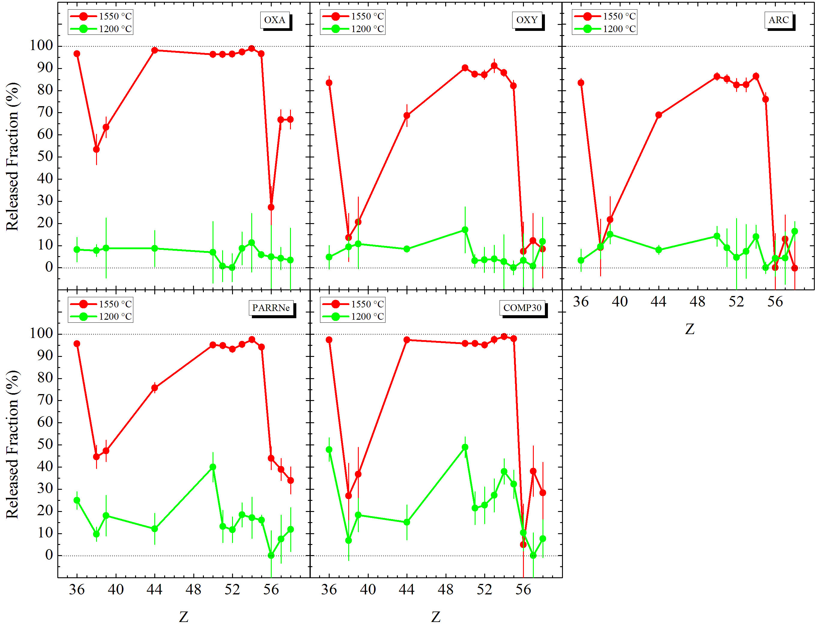  (a) | 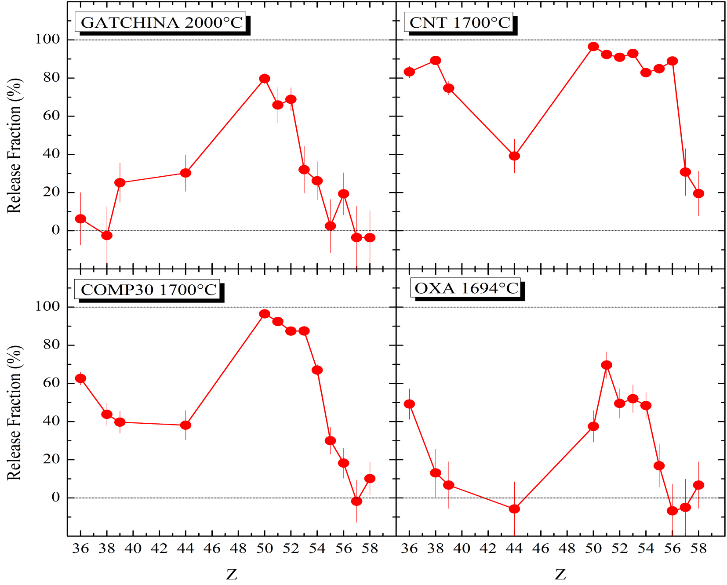  (b)
Figure 1: Release measurements for (a) preliminary tests to validate the method, (b) tests after improvements of the method.

B. Hy et al.,” An off-line method to characterize the fission product release from uranium carbide-target prototypes developed for SPIRAL2 project”, Nuclear Instruments and Methods in Physics Research B 288 (2012) 34 – 41 DOI: 10.1016/j.nimb.2012.04.031

