Next-EBCB
very fast charge breeding, production of fully stripped ions and cw beams
with next generation Electron Beam Charge Breeder

A. Shornikov, F. Wenander

Motivation

Next generation Electron Beam Charge Breeders (Next-EBCB) can boost the performance of linear post-accelerators for fixed-target experiments as well as for injection into storage rings [1]. A Next-EBCB can be a unique source of very heavy ions (U/Th) in few-electron configurations and up to medium-heavy (Ba) in bare state. The main limitations of EBCB devices are their limited space-charge capacity and the pulsed ion extraction. Both can be improved in the next generation so that the breeder will not compromise the overall facility performance.

Although being complex and costly devices requiring some R&D, EBCB present a cost effective solution for the overall project. By decreasing the A/q ratio of the extracted ions one can reduce the length and therefore the cost of the linac. Next-EBCB can also be more effective in production of very low A/q for storage ring injections compared to foil stripping after the linac [1].

Several parameters should be improved simultaneously by an order of magnitude [2] compared to present EBCB several designs. The REXEBIS values are given within paranthesis:

- High electron beam energy up to 150 keV to ionize deep shells and produce lowest requested A/q (5kV);
- High electron-current density of about 10⁴ A/cm² so the breeding rate becomes compatible with the linac time structure, experiment data acquisition and lifetime of requested isotopes (100 A/cm²);
- High breeder capacity of about 10¹¹ charges so all produced exotic isotopes can be loaded into the breeder without losses (10⁹).

The performance of the Next-EBCB as well as existing breeders at ISOL facilities can be further improved by converting them into continuous highly charged ion-sources by means of intermediate trapping and debunching devices.

Apart from its direct impact on RIB/ ISOL facilities the R&D activities suggested in this project will also benefit other facilities such as injectors of highly charged stable isotope beams for space-related material research, biological experiments with heavy ions and solid state surface spectroscopy with highly charged ions.

Starting ground for the project

The main challenge for Next-EBCB is to produce the electron beam with requested energy, current and compression. Furthermore, one has to prove that ion injection and extraction from such an electron beam can be done efficiently. One needs to produce the electron beam, ensure it effectively captures 1+ ions, keep the ions while they undergo charge breeding, minimize the emittance growth and effectively extract them. It is important to mention that the actual electron beam parameters and machine physics studies can only be carried out with a fully equipped EBCB test stand, featuring a 5-6 T magnetic field and suitable for Brillouin-type electron guns, equipped with high voltage infrastructure and properly designed high-power electron collector.

Our proposal for Next-EBCB R&D is based on a unique combination. There is already an initiated program for the study of a High Energy Compression and Current (HEC²) electron gun by BNL and CERN, which takes advantage of an existing and fully functioning EBCB test stand at BNL. At the moment, June 2013, an important step in the HEC² program has been reached as the first version of the HEC² electron gun for short pulse test operation according to the BNL design [3] has been built at CERN. In summer 2013 it will be brought to BNL for tests at the BNL test stand.

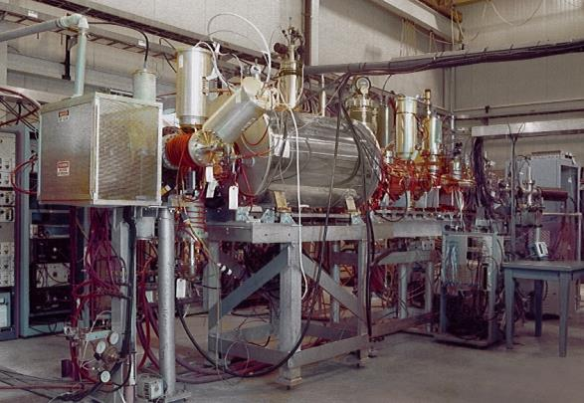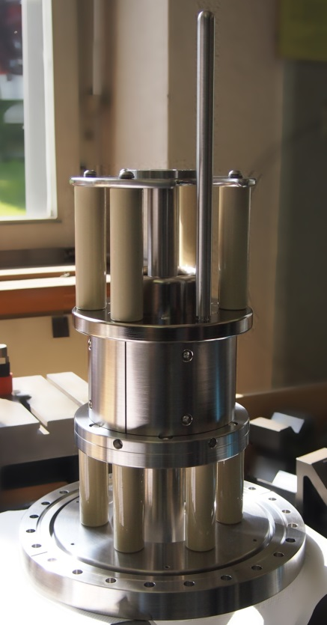
Figure 1 Left: BNL EBCB test stand. Suitable for HEC² tests and operational. Right: HEC² electron gun pre-assembled at CERN.
This test configuration shall provide proof-of-principle at energies up to 50 kV in short pulse operation mode.
R&D program

Operation at full voltage with long pulses and studies of the machine physics will require some changes to the gun design and the test stand (see Figure 2). The R&D to enable long pulsed and continuous electron beam operation includes improving the discharge resistance of the gun, modification of the electron repeller in the collector, and improving high-voltage and power ratings of isolation components and feedthroughs.

The modifications of the collector are motivated by the fact that HEC² electron beam spreads in the collector area in a different way compared to a low compression beam of original TestEBIS design. The repeller electrode group should be modified to avoid damage of the optics when high power beam sweeps electrodes not connected to sufficient water cooling for a long period.

The machine physics R&D includes studies of interaction of the high compression beam with injected ions. The key questions are the breeder acceptance and the extracted ion beam emittance. To prevent emittance growth of the extracted beam and evaporative losses of the highest charge states, the implementation of in-breeder ion-ion cooling using low-charge state ions is a separate subtask for the machine development.
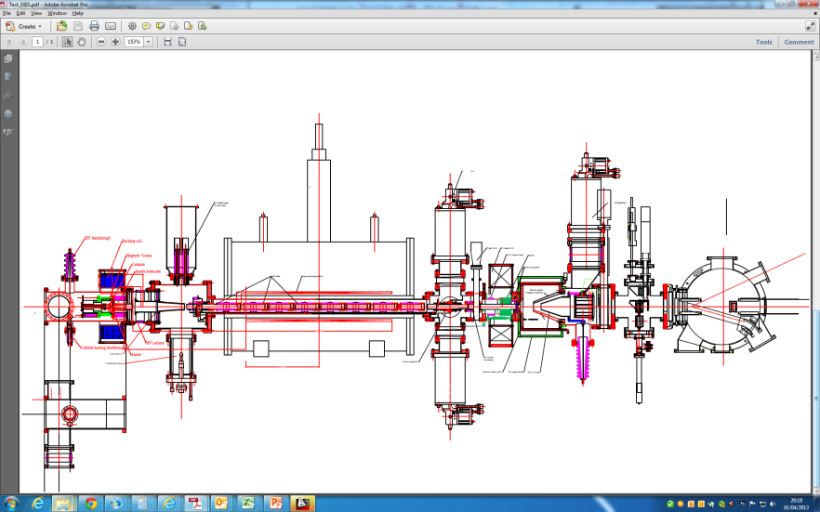
The first short-pulse test to be done using the BNL Test-EBIS
with the entire gun chamber replaced by the new one

Future cw tests will require some hardware development:
collector optics
gun discharge resistivity
HV isolation
feedthrough power rating
Figure 2. Hardware development and improvements for advanced machine physics studies
The most research intensive area is to suppress magnetron discharges at the gun, where they inevitable will start to glow if the voltage will be kept long enough in the presence of crossed electric and magnetic fields. The electron gun design developed by BNL is based on electron guns for high power RF tubes. In the RF tubes short pulsed operation with parameters close to requested for Next-EBCB was demonstrated. However, extinguishing the magnetron discharge is a new area. This requires careful 3D modelling (see Figure 3) as the axial symmetry shall be broken. After being numerically proven an updated discharge-free version of the gun shall be tested in long pulse/continuous operation mode.

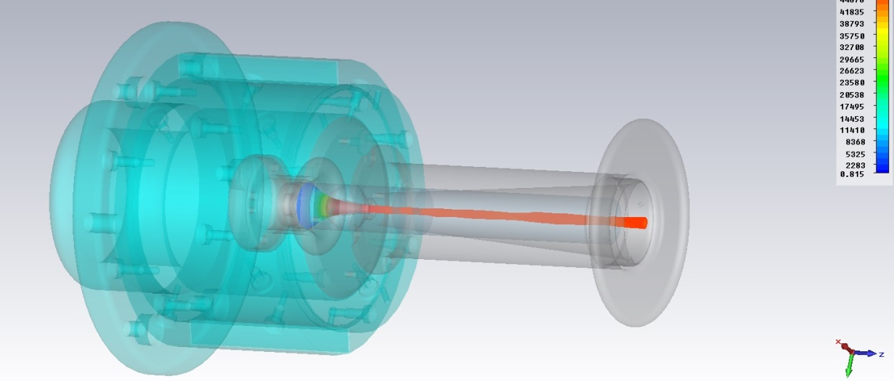
Figure 3. First test of full 3D space-charge limited electron beam with 49 keV energy and 10 A current using the CST software. The model is being integrated at CERN into CAD design workflow, has 2.74 M nodes, and the beam is created by 6170 individual trajectories. The simulation covers all aspects from emission to guiding magnetic field.

The current early phase of the program is entirely funded by the European side while BNL provides in-kind contribution in form of intellectual property (drawings, simulations, consulting), some components and access to the test infrastructure. Only limited manpower can be allocated on BNL side. The current financial support by the EU funds will end by October 2014. Therefore to continue R&D benefiting future ISOL facilities we request support in the framework of ENSAR-2 program.

Links to other ion sources projects and TNA in this JRA

In parallel with the HEC² activities at CERN, there is an on-going project at GANIL aiming to use a debunching RF Paul trap for conversion of pulsed beam extracted beams from an EBCB into a quasi-continuous debunched beam (see contribution by P. Delahaye and E. Traykov elsewhere in this document). This can benefit both present and future ISOL facilities. Apart from its own project CERN could contribute to the debuncher project by operating the TWINEBIS – EBCB as a test ion source for the debuncher trap, if the additional required manpower will be covered by an external budget.

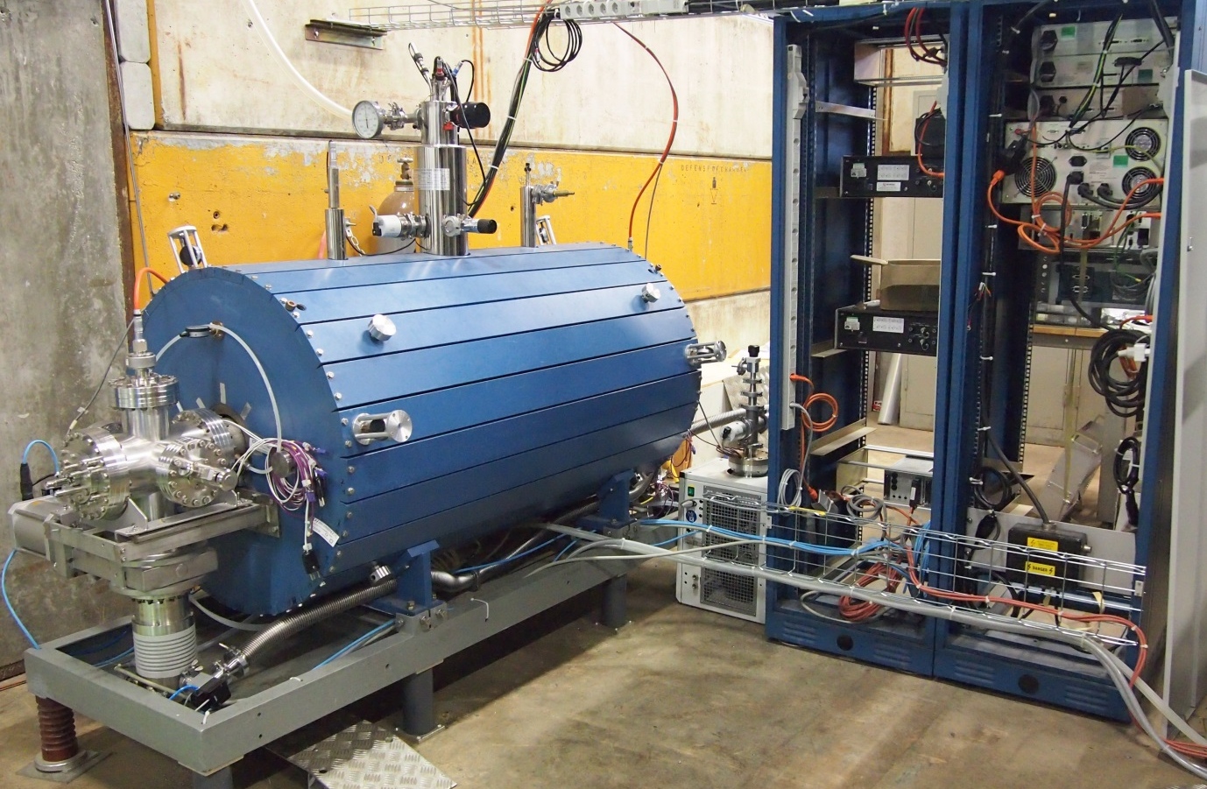
Figure 4. TWINEBIS is a replica of REXEBIS at CERN suitable as a test stand for the debunching trap and a test stand for intermediate upgrades of REX-like breeders. Presently getting operational after relocation from Manne Siegbahn Laboratory (Stockholm) to CERN.

References

[1] | M. Grieser et al., "Storage ring at HIE-ISOLDE," Eur. Phys. J. Special Topics, vol. 207, pp. 1-117, 2012. [Online]. http://link.springer.com/article/10.1140%2Fepjst%2Fe2012-01599-9
[2] | A. Shornikov, A. Pikin, R. Scrivens, and F. Wenander, "Design study of an upgraded charge breeder for ISOLDE," Nuclear Instruments and Methods in Physics Research Section B, vol. -/-, no. -/-, pp. -/-, accepted for publication 2013.
[3] | A. Pikin, E. N. Beebe, and B. Raparia, "Simulation and optimization of a 10A electron gun with electrostatic compression," Review of scientific instruments, vol. 84, p. 033303, 2013. [Online]. http://dx.doi.org/10.1063/1.4793773

We would like to acknowledge HIE-ISOLDE design study covering the present material costs, and manpower covered by Marie Curie Initial Training Network Fellowship of the European Community’s FP7 Programme under contract number (PITN-GA-2010-264330-CATHI)

