Multi-reflection time-of-flight mass analyzer for analysis, optimisation, mass separation and precision mass measurements of radioactive ion beams
Robert N. Wolf, Institut für Physik, Ernst-Moritz-Arndt-Universität Greifswald, Felix-Hausdorff-Str. 6, 17489 Greifswald
Multi-reflection time-of-flight (MR-ToF) mass analyzers are among the most recent developments in mass spectrometry and manipulation of low energy (keV) ion beams. They offer highest mass resolving power on the order of R=m/∆m=100,000 on short time scales of a few tens of milliseconds. Therefore, they are ideally suited as, e.g., mass analyzers of short-lived ion beams, mass purifiers in combination with a fast ion selector and high-precision mass spectrometers. Although conceptually developed and tested already in the early 1990s [1], the application to radioactive ion beams was achieved not until recently. Several groups have developed MR-ToF devices for nuclear physics investigations; the SLOW-RI team at RIKEN [2-4], the FRS-ioncatcher group at GSI [5-7] and the ISOLTRAP collaboration at ISOLDE/CERN [8,9]. Furthermore, this type of device is under development at many other radioactive ion-beam facilities [10,11]. In the following, the design and achievements in performance and application versatility of the MR-ToF mass analyzer installed at ISOLTRAP/CERN will be presented.
Figure 1 shows a sketch of this MR-ToF mass analyzer, visualizing its principle of operation and the two general application modes. An ion bunch of short time distribution, typically some tens of nanoseconds – ∆t_{FWHM}≈60ns in the case of ISOLTRAP where it comes from a radio-frequency-quadrupole ion-beam buncher and cooler (in short RFQCB) with a mean kinetic energy of 3.1keV – is injected into the MR-ToF mass analyzer [12]. The analyzer consists of two electrostatic ion mirrors between which the bunch is electrostatically confined in radial and axial direction. The injection and ejection is achieved via an in-trap lift electrode which facilitates the operation and the performance of the analyzer [13]. Due to the folded flight path of the ion bunch of up to several kilometres, which corresponds to flight times t of several tens of milliseconds, high mass resolving powers R=m/∆m=t/(2*∆t) on the order of 100,000 can be reached, sufficient to resolve most isobaric ions. Several of a broad range of possible applications are described in the following.
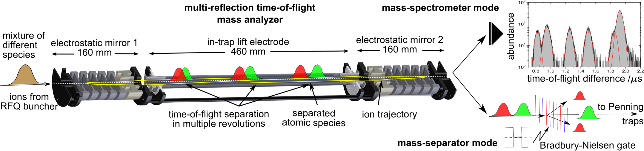
Fig. 1: Sketch of the operation principle of the ISOLTRAP MR-ToF MS as a mass analyzer and precision spectrometer in combination with an ion detector (top right) and as a mass separator in combination with a Bradbury-Nielsen beam gate (bottom right) [9].
High-resolution ion beam composition identification, analysis and monitoring for various ion-beam production and ionisation developments and characterisation
Figures 2 and 3 show examples of applications where the MR-ToF mass analyzer was used to characterise the influence of different parameters affecting the radioactive ion-beam production. Due its fast (milliseconds) cycle, non-scanning mode and high mass resolving power, the direct evolution of the yield of the different species can be recorded. In Fig. 2, the target temperature was increased which resulted in a yield increase for short-lived copper isotopes. Due to the complexity of the delivered beam, containing short-lived nuclides, stable nuclides and molecular sidebands on this particular mass number, other beam-analysis techniques such as Faraday cups or decay stations fail to detect the full composition qualitatively and quantitatively [9]. In Fig. 3, resonant laser ionisation (RILIS) for short-lived Au isotopes was used to produce a gold beam, which was contaminated by the corresponding Tl isotopes. The Au component can be unambiguously identified by switching off the laser. The evolution of the Au yield was monitored with the MR-ToF mass analyzer by gating only on the Au isotopes and scanning the first RILIS excitation step. This resulted on the one hand in the optimized excitation wavelength for this particular atomic transition and on the other hand revealed the isotope shift and the hyperfine structure of the isotope. In comparison to Faraday cups, this method is orders of magnitude more sensitive and quasi background free [9,14]. In contrast to yield measurements with a decay station, it is independent of the branching ration and not limited by an upper half-life. A third example, shown in Fig. 3, is the sampling of the release curve of a particular species from the target and ion source system. Due to the MR-ToF MS’ short experimental cycle time of only a few milliseconds, even these fast processes can be monitored and optimized. By varying the delay after each proton pulse before ion injection into the RFQCB, and subsequent yield analysis, the effusion and diffusion times of the target can be evaluated [15].
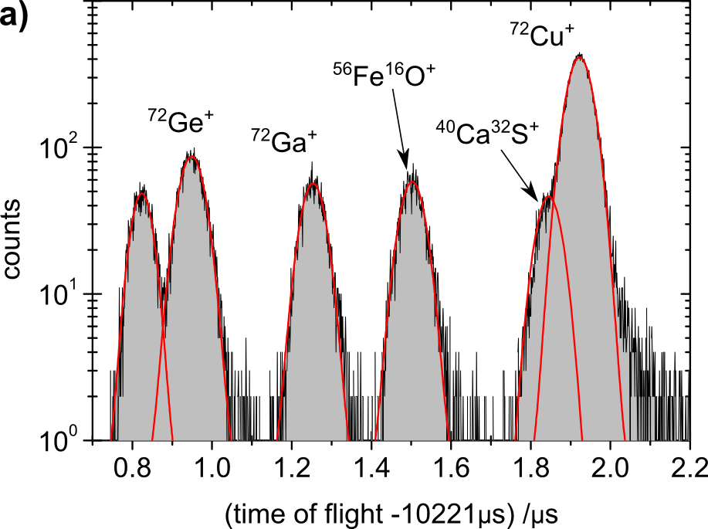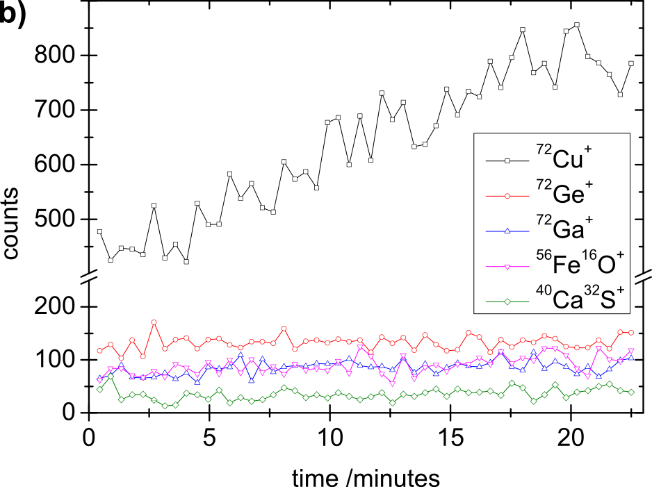
Fig. 2: a) Integral time-of-flight spectrum for 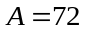 as delivered from ISOLDE during heating of the target material; b) Number of counts of the isotopes from the spectrum on the left as a function of the time and increase of the target heating by approximately 70°C [9].
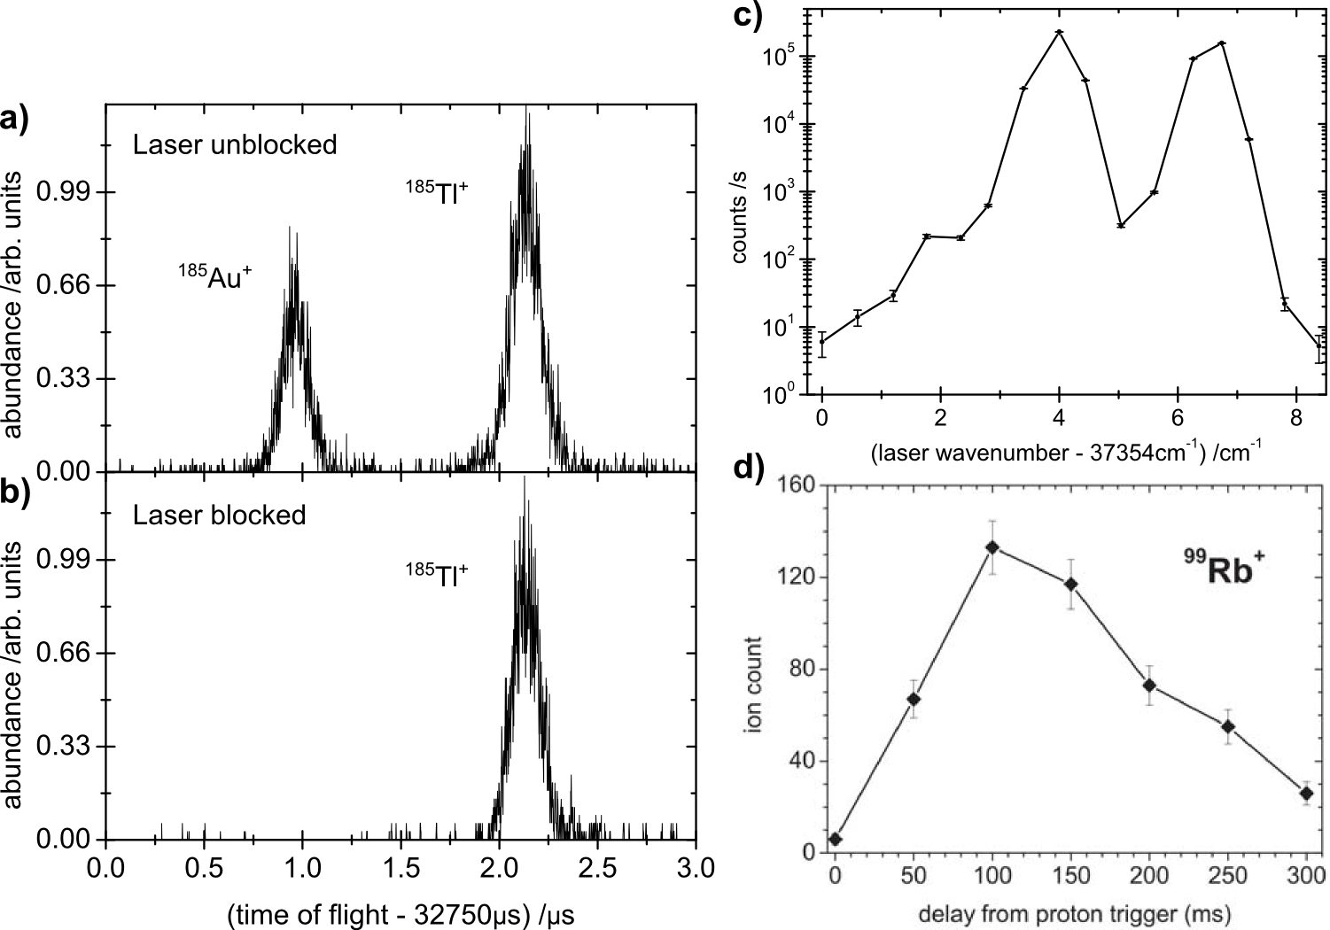
Fig. 3: left: 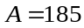 time-of-flight spectra after 1500 revolutions in the MR-ToF MS. a) The RILIS lasers were tuned to ionize 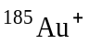 atoms. The clear separation from 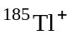 isotopes enables a background-free gold-yield analysis. b) Furthermore, blocking the laser beam unambiguously identifies the gold isotope. [9] c) Signal intensity of (scaled to RFQ accumulation time of ), representing the ionization efficiency, as a function of the wavenumber of the RILIS first excitation step (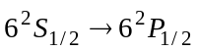; the two resolved resonances of the hyperfine-structure correspond to the transitions 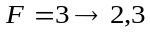 (left peak) and 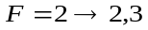 (right peak) ) . The laser line width was 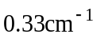. [9] d) Scan of the target and ion source release curve by varying the delay between the proton irradiation of the target and the start of the RFQCB ion accumulation. [15]
MR-ToF mass purification
In combination with fast ion deflector, e.g. a Bradbury-Nielsen gate [6,16], the MR-ToF separated species can be selectively addressed for further transfer to a subsequent experimental step. So far at ISOLTRAP, a contamination suppression of four orders of magnitude has been reached [12]. The purified bunches can, e.g., be used to supply Penning traps for high-precision mass measurements [17] or any other investigation. For example, the MR-ToF MS will offer a fast alternative for trap-assisted decay-spectroscopy experiments at ISOLTRAP, where currently the purification is performed by Penning-trap mass separation [18].
MR-ToF mass measurements
The MR-ToF device can also be used as a mass spectrometer of its own right which is very fast and sensitive, i.e. can be applied to nuclides of short half-lives (down to a few milliseconds) which are available with only very low yields – even a few counts of the ions of interest are sufficient. As most often, signals of other isobaric species are found in the time-of-flight spectra, these provide ideal (because close-lying) reference mass values for the calibration. Thus, mass measurements with low uncertainty, i.e., δm/m≈10⁻⁷, are possible. This opens the possibility to explore the so far unknown masses of nuclides on the outskirts of the chart of nuclides. Particular applications are mass measurement in regions approaching the r-process path, rp-process path or nuclides relevant for neutron-star crusts. A recent first application was the mass measurement of the neutron-rich calcium isotopes ^{53,54}Ca [19].
References
- H. Wollnik and M. Przewloka, Int. J. Mass Spectrom. Ion Proc. 96 (1990) 267-274.
- Y. Ishida, M. Wada, Y. Matsuo, I. Tanihata, A. Casares, and H. Wollnik, Nucl. Instr. and Meth. in Phys. Res. B 219-20 (2004) 468-472.
- Y. Ishida, M. Wada, and H. Wollnik, Nucl. Instr. and Meth. in Phys. Res. B 241 (2005) 983-985.
- P. Schury, K. Okada, S. Shchepunov, T. Sonoda, A. Takamine, M. Wada, H. Wollnik, and Y. Yamazaki, Eur. Phys. J. A 42 (2009) 343 - 349.
- W. R. Plaß, T. Dickel, M. Petrick, D. Boutin, Z. Di, T. Fleckenstein, H. Geissel, C. Jesch, C. Scheidenberger, and Z. Wang, Eur. Phys. J. Special Topics 150 (2007) 367-368.
- W. R. Plaß, T. Dickel, U. Czok, H. Geissel, M. Petrick, K. Reinheimer, C. Scheidenberger, and M. I.Yavor, Nucl. Instr. and Meth. in Phys. Res. B 266 (2008) 4560 - 4564.
- W. R. Plaß, T. Dickel, and C. Scheidenberger, Int. J. Mass Spectrom., in print (2013), http://dx.doi.org/10.1016/j.ijms.2013.06.005
- R. N. Wolf, M. Eritt, G. Marx, and L. Schweikhard, Hyperfine Interact. 199 (2011) 115-122.
- R. N. Wolf, F. Wienholtz, D. Atanasov, D. Beck, K. Blaum, C. Borgmann, F. Herfurth, M. Kowalska, S. Kreim, Y. A. Litvinov, D. Lunney, V. Manea, D. Neidherr, M. Rosenbusch, L. Schweikhard, J. Stanja, and K. Zuber, Int. J. Mass Spectrom., in print (2013), http://dx.doi.org/10.1016/j.ijms.2013.03.020
- A. Piechaczek, V. Shchepunov, H. Carter, J. Batchelder, E. Zganjar, S. Liddick, H. Wollnik, Y. Hu, and B. Griffith, Nucl. Instr. and Meth. in Phys. Res. B 266 (2008) 4510 - 4514.
- J. Dilling, TITAN/Triumf; G. Savard, Caribu/ANL; A. Jokinen, IGISOL/YFL; P. Delahaye, GANIL
- R. N. Wolf, D. Beck, K. Blaum, C. Böhm, C. Borgmann, M. Breitenfeldt, F. Herfurth, A. Herlert, M. Kowalska, S. Kreim, D. Lunney, S. Naimi, D. Neidherr, M. Rosenbusch, L. Schweikhard, J. Stanja, F. Wienholtz, and K. Zuber, Nucl. Instr. and Meth. in Phys. Res. A 686 (2012) 82 - 90.
- R. N. Wolf, G. Marx, M. Rosenbusch, and L. Schweikhard, Int. J. Mass Spectrom. 313 (2012) 8 - 14.
- B. March et al., EMIS proceedings 2012, Nucl. Instr. and Meth. in Phys. Res. B, accepted
- S. Kreim et al., EMIS proceedings 2012, Nucl. Instr. and Meth. in Phys. Res. B, accepted
- N. Bradbury and R. Nielsen, Phys. Rev. 49 (1936) 388-393.
- R. N. Wolf, D. Beck, K. Blaum, C. Böhm, C. Borgmann, M. Breitenfeldt, N. Chamel, S. Goriely, F. Herfurth, M. Kowalska, S. Kreim, D. Lunney, V. Manea, E. Minaya Ramirez, S. Naimi, D. Neidherr, M. Rosenbusch, L. Schweikhard, J. Stanja, F. Wienholtz, and K. Zuber, Phys. Rev. Lett. 110 (2013) 041101.
- M. Kowalska, S. Naimi, J. Agramunt, A. Algora, D. Beck, B. Blank, K. Blaum, C. Boehm, C. Borgmann, M. Breitenfeldt, L. M. Fraile, S. George, F. Herfurth, A. Herlert, S. Kreim, D. Lunney, E. Minaya-Ramirez, D. Neidherr, M. Rosenbusch, B. Rubio, L. Schweikhard, J. Stanja, and K. Zuber, Nucl. Instr. and Meth. in Phys. Res. A 689 (2012) 102-107.
- F. Wienholtz, D. Beck, K. Blaum, C. Borgmann, M. Breitenfeldt, R. B. Cakirli, S. George, F. Herfurth, J. D. Holt, M. Kowalska, S. Kreim, D. Lunney, V. Manea, J. Menendez, D. Neidherr, M. Rosenbusch, L. Schweikhard, A. Schwenk, J. Simonis, J. Stanja, R. N. Wolf, and K. Zuber, Nature 498 (2013) 346-349.

