Title
Results of experiment ISXXX  Website (if applicable): | Your name (for the X collaboration)

This is the template for your contributions to the ISOLDE newsletter 2016. Please use exactly this format to prepare your text and figures and do not exceed one page. The font should be Arial 10, spacing multiple at 1.25. To make sure that format is not changed, please use right click, “Keep text only” when pasting text.
When inserting figures, please right click on the figure box shown below and use the “Change Picture” option. This will ensure that figure settings are not changed.

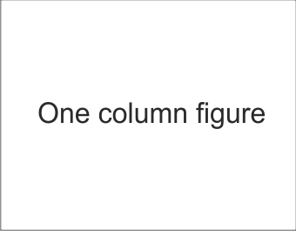
Fig. 1: Maximum width for single-column figure is 9 cm. Insert single-column figure by using right-click, “Change Picture” option on the rectangle above

The text is organized on two columns. Please leave the second page in, so that the column width doesn’t change.

[1] Reference 1.
[2] Reference 2.

