|  |  |
| --- | --- |
| Description : Macintosh HD:Users:etudiant01:Desktop:Charte graphique:Papeterie:En-tete:A4-01.eps |  |

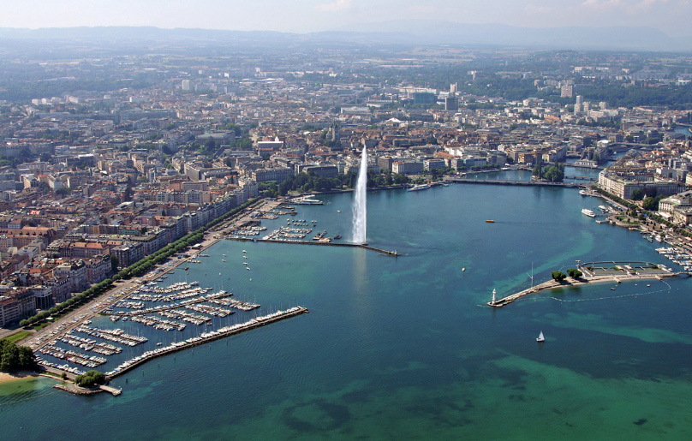

EMIS2018

<http://indico.cern.ch/e/EMIS2018>

First Circular June 2017

The International Conference on Electromagnetic Isotope Separators and Related Topics (EMIS) will be held at CERN, the European Organization for Nuclear Research, in Geneva, Switzerland, from 16th to 21st September 2018. The EMIS-2018 conference will be hosted by ISOLDE, CERN which is celebrating 50 years of radioactive beams.

EMIS is the long-running flagship conference series on techniques in the field of low-energy nuclear science. EMIS-2018 will be the eighteenth conference in this series. Recent conferences in this series have been held in Grand Rapids, MI, USA (2015), Matsue, Japan (2012), Deauville, France (2007), and Victoria, B.C. Canada (2002).

Scientific topics of EMIS-2018 include:

* Isotope production, target and ion source techniques
* Techniques related to high-power radioactive ion beam production
* Low-energy and in-flight separators
* Storage rings
* Ion guide, gas catcher, and beam manipulation techniques
* Ion optics and spectrometers
* Ion traps and laser techniques
* Instrumentation for radioactive ion beam experiments
* Applications of radioactive ion beams

**Participation**

All scientists, post-docs and graduate students that are interested in research and development related to production of radioactive nuclear beams and their scientific use are encouraged to attend.

**Important Dates**

* EMIS-2018 Conference 16-21 September, 2018
* Tentative dates for the organization of the meeting:
  + First Circular – June 2017
  + Second Circular – Call for Abstract Contributions – January 2018
  + Deadline for Contributed Abstracts – End February 2018
  + Conference Program - available May 2018
  + End of Early Registration and Hotel Reservations at reduced rate – 31 July 2018

**EMIS-2018 Venue**

EMIS-2018 will be held from Sunday, 16th September to Friday afternoon, 21st September at CERN, the European Organization for Nuclear Research, in Geneva, Switzerland. Geneva is situated in some of Europe’s most beautiful scenery, between lake and mountains. In the very heart of Europe, Geneva has a long tradition as a venue for major meetings and is a host city to many international organizations such as the United Nations, the World Health Organization, the International Labour Office and the International Red Cross, as well as CERN. Registration and a welcome reception on the Sunday evening will be held in the CERN Globe while all of the sessions will be held in the main auditorium at the heart of CERN itself.

**Accommodation**

A block of rooms will be reserved for participants at the CERN Hostel from Saturday 15th to Saturday 22nd September. There are also a large number of hotels in the local area in both France and Switzerland. More details will be made available later.

**Travel**

CERN is situated on the border of Switzerland and France, on the outskirts of the city of Geneva which has an international airport (GVA, 15 minutes from CERN) offering direct flights to more than 100 international destinations. Road and rail facilities radiate from Geneva to provide rapid access to the rest of Switzerland and Europe. Geneva train station (Cornavin, 20 minutes from CERN by tram) offers Inter-city trains to France, Spain, Italy and Germany. Geneva’s TPG public transport network is excellent with trams crossing the town centre every few minutes and frequent connections to CERN and the airport.

**Conference Program**

EMIS-2018 will have a five-day program. Registration and a welcoming reception are planned for Sunday, 16th September in CERN’s Globe of Science and Innovation. Conference excursions are tentatively planned for the afternoon of Wednesday 19th September and the conference banquet will be held on Thursday 20th September. It is planned to include at least one poster session and a public lecture in the conference program. An opportunity to visit the ISOLDE facility will be provided during the conference.

**Sponsorship**

IUPAP Sponsorship has been applied for. To secure IUPAP sponsorship, the organizers have provided assurance that EMIS-2018 will be conducted in accordance with IUPAP principles as stated in the IUPAP resolution passed by the General Assembly in 2008. In particular, no bona fide scientist will be excluded from participation on the grounds of national origin, nationality, or political considerations unrelated to science.

**International Advisory Committee**

The scientific program for EMIS-2018 will be developed with the assistance of the International Advisory Committee:

Navin Alahari (GANIL, France)  
Faical Azaiez (iTemba Labs, South Africa)  
Klaus Blaum (MPI-Heidelberg, Germany)  
Yorick Blumenfeld (IN2P3-IPN-Orsay, France)  
Georg Bollen (MSU-NSCL, USA)  
Angela Bracco (INFN, U-Milano, Italy)  
Alok Chakrabarti (VECC, India)  
Jens Dilling (TRIUMF, Canada)  
Andrey Fomichev (JINR, Russia)  
Simone Gilardoni (CERN, Switzerland)  
Fabiana Gramegna (LNL, Italy)  
Sunchan Jeong (IBS-RAON, South Korea)  
Ari Jokinen (JYFL, Finland)  
Jacques Lettry (CERN, Switzerland)  
Rubens Lichtenthaler (Univ. Sao Paolo, Brazil)  
Bettina Mikulec (CERN, Switzerland)  
Michael Paul (SOREQ, Israel)  
Karsten Riisager (Aarhus University, Denmark)  
Hide Sakai (RIBF/RIKEN, Japan)  
Guy Savard (ANL, USA)   
Christophe Scheidenberger (GSI/FAIR, Germany)   
Piet van Duppen (KU-Leuven, Belgium)   
Fredrick Wenander (CERN, Switzerland)

Yuhu Zhang (IMP, CAS, China)  
Victor Zamfir (ELI, Romania)

**Local Organizing Committee:**

Richard Catherall, CERN (Chair)

Gerda Neyens, CERN (Co-chair)

Maria Jose Garcia Borge, CERN

Karl Johnston, CERN

Valentin Fedosseev, CERN

Sebastian Rothe, CERN

Magdalena Kowalska, CERN

Jenny Weterings, University of Oslo

**Contacts**

Please address questions about the EMIS-2018 conference to [EMIS2018@cern.ch](mailto:EMIS2018@cern.ch) .